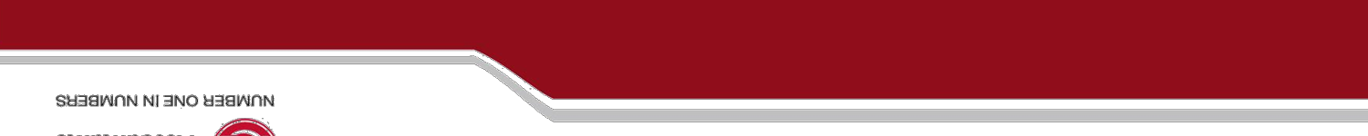

Registered Office Address:

Flat No. 10 E, DCM Building 16, B.K. Road

Back Office Address:

288 K Purdilpur, Gas Godam Gali, Vijay Chowk, Golghar

Contact:

New Delhi 110001

Gorakhpur 273001

31/03/2021

**TO WHOMSOEVER IT MAY CONCERN**

This letter certifies that Mr. Nitesh Nishad was an employee in the role of Sr. Business Analyst with Red Earth Migration during the period beginning 01/02/2019 andending 20/03/2021.

During his time with Red Earth Migration, Nitesh has remained dedicated and loyal to his work and responsibilities with our company. His responsibilities included daily Maintenance of record in excel and BI Visualizations. He has done an exemplary job while in this role. Nitesh has always maintained a professional and courteous attitude and appearance while with our company.

We wish him all the best in his future career opportunities.

.

Sincerely

Simon Arpit Das Manager

Red Earth Migration Pvt. Ltd.