Math 3B Midterm

|  |  |
| --- | --- |
| Name: |  |
| Date: |  |
| Results: |  |

# Instructions

Read the entire question! Circle the right answer!

# Part I: Multiple Choice

1. What system of measurement does the United States use?
2. Imperial
3. Metric
4. Gaussian
5. Feet
6. How many cups are pint?
7. 2
8. 4
9. 6
10. 8
11. What are the two systems of measurement? (Circle 2)
12. Imperial
13. Metric
14. British
15. Meter
16. For the following, write down all the units in the METRIC system for WEIGHT:
17. Write down all the units in the IMPERIAL system for LENGTH
18. Fill in the blank

1ft = ______ inches

1 yard = _____ ft

1 mile = ______ ft

1 meter = ______ cm

1 centimeter = ______mm

1 kilometer = ______ m

1 Gallon = _____ quarts

1 quart = _______ pints

1 pint = ______ cups

1 liter = ______mL

1 pound = ______ oz

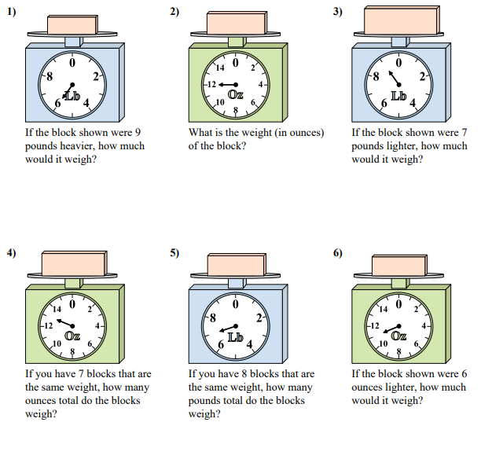

7()

**100ft**

**A** 24 inches **B**

C

30 yards

7a) What is the distance between A and C? 7b) What is the distance from A, back to A?