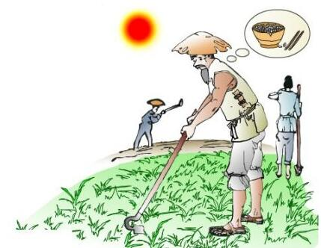

**Mǐn Nóng**  
 **悯 农** Lǐ shēn (Táng)  
 李 绅（唐）

Chú hé rì dāng wǔ,   
锄 禾 日 当 午，  
hàn dī hé xià tǔ.   
汗 滴 禾 下 土。  
Shuí zhī pán zhōng cān,   
 谁 知 盘 中 餐，  
lì lì jiē xīn kǔ.   
粒 粒 皆 辛 苦。

“悯农”就是怜悯农民的意思。

"悯农(mǐn nóng)" means showing sympathy with the peasants.

给禾苗锄草的时候，正是太阳当空照的中午，农民的汗水滴落进禾苗下面的泥土里。有谁知道那盘子里的饭食，一粒一粒中都凝聚着农民的千辛万苦。

It is at noon that the sun hangs high up in the sky when the peasants are getting rid of the weeds in the fields. Their sweat runs down and mixes with the soil. Do you know that each grain of rice in your bowl is the result of their hardship and toil?

这首诗通过描写农民劳作时的情景，告诫我们餐桌上的饭食都是来之不易的。表现了诗人对不避严寒酷暑、风霜雨雪、终年辛勤劳作的农民的深切同情。

The poem tell us the peasants working in the field, telling people that the food on table does not come by easily, which shows the poet's compassion towards the peasants who work hard all year around despite the hardship and bad weather.