第一学期第一周看图写话（２０分钟）
Choose one of the following pictures. In the box at right, use your imagination, with GOOD Chinese, type five to ten sentences of what you would like to say of/about/on the picture. You can type anything you want to, but make sure to be positive and respectful.

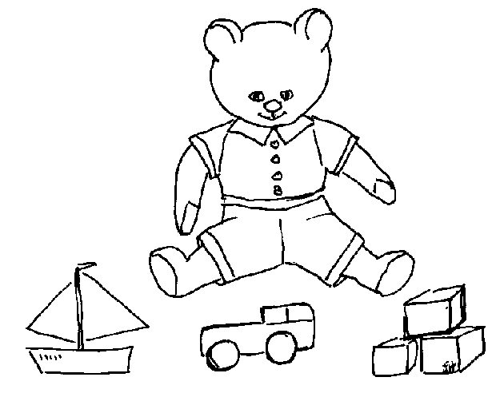


第一学期第二周看图写话（２０分钟）
Choose one of the following pictures. In the box at right, use your imagination, with GOOD Chinese, type five to ten sentences of what you would like to say of/about/on the picture. You can type anything you want to, but make sure to be positive and respectful.

