**6th Grade Math Diagnostic Test**

Estimate the value.

1. $3942 × 7≈$ 28,000

Find the value of:

1. $4+8 × 2÷16-7=$-2

Solve.

1. $81 × 1.29=$ 104.49
2. $1421÷7000=$.203

Express in simplest form.

1. $\frac{9}{16}÷6=$.09375 or 3/32
2. $5\frac{1}{9}-2\frac{2}{3}=$ 2 4/9 or 22/9

Express as a percentage.

1. 215 out of 500

43%

Find the equivalent measure.

$\frac{4}{5}min=____48_____s$

Solve.

1. What fraction of $2 is 75¢? (Express fraction in simplest form.)

3/8

1. Find the average of 21.5, 18.2, and 5.3.

15

1. Write the missing number (ratio).

30 : ____15___ = 6 : 3

1. A pole, 135 cm long, is painted red, white, and blue in the ratio 3 : 4 : 2. What length of the pole is painted white?

60

1. The normal price of a camera was $80. At a sale it was sold at a discount of 15%. What was the selling price of the camera?

$68

1. The length of one side of a cube is 1 ft. What is its volume in cubic inches? (Do not have to calculate the number.)

1728 inches or 12 by 12 by 12

Find the area of the shaded figures.

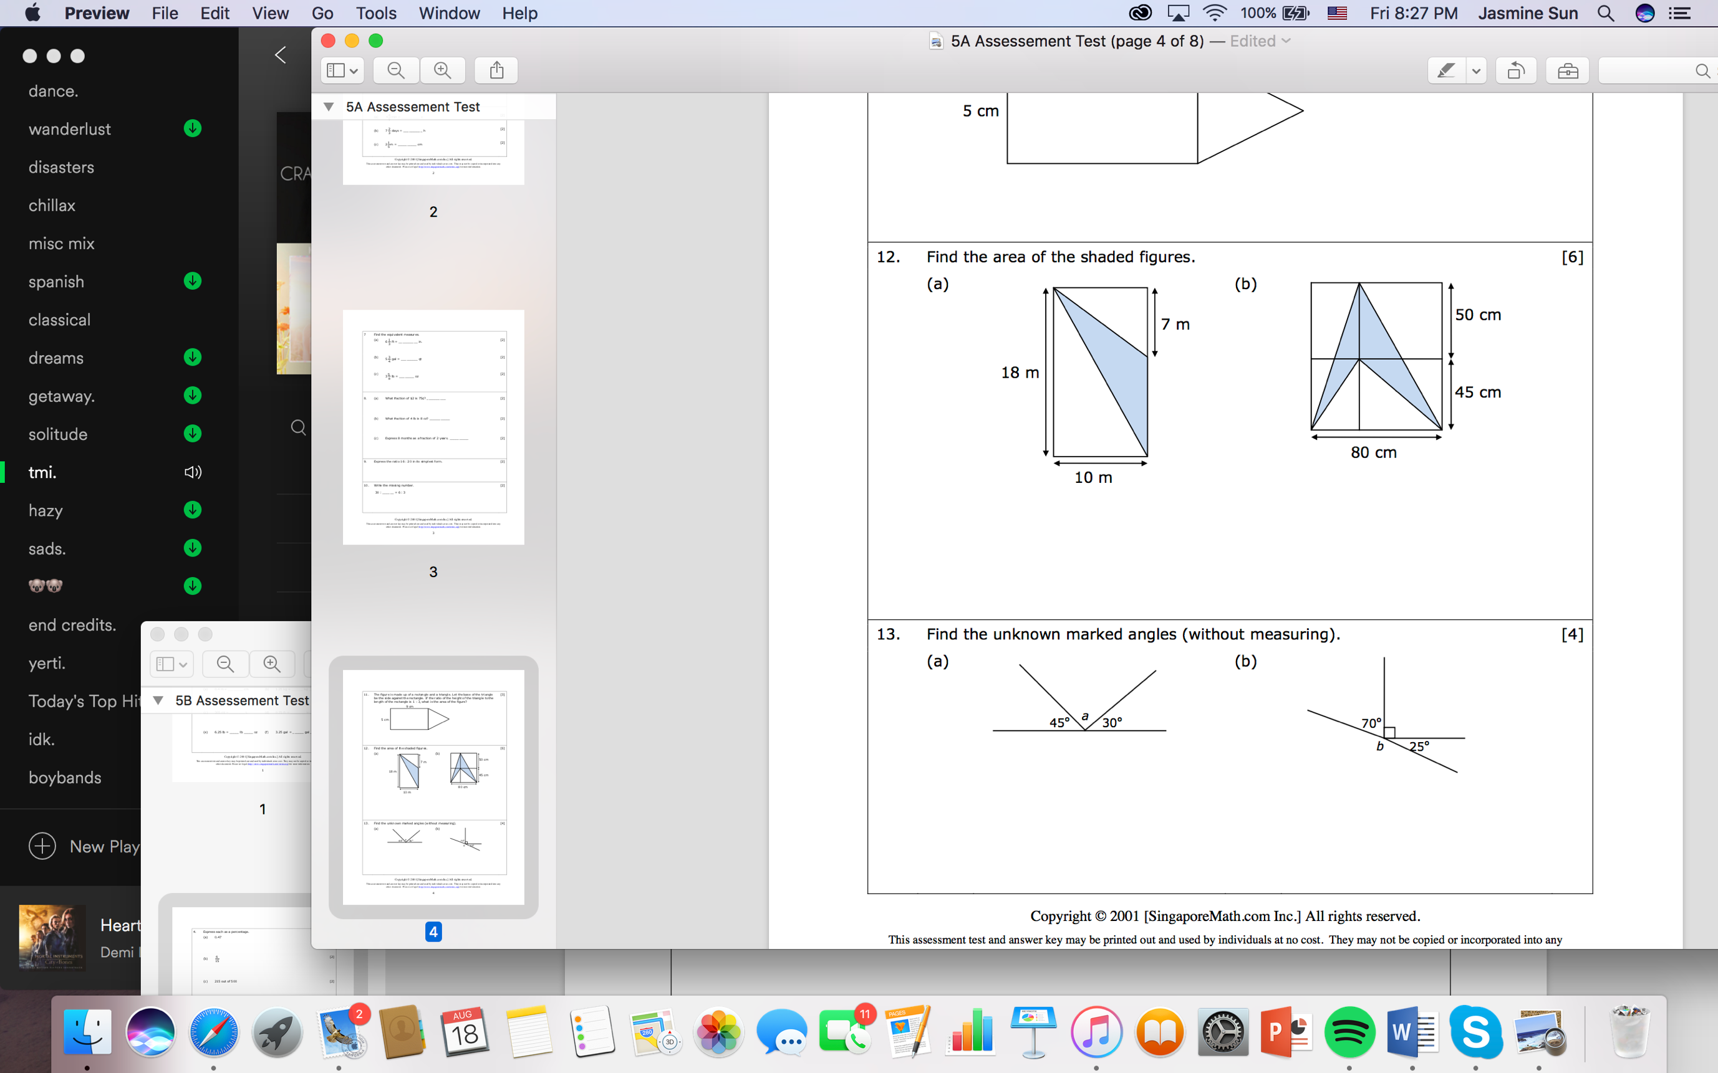55m squard

Find the unknown angle.

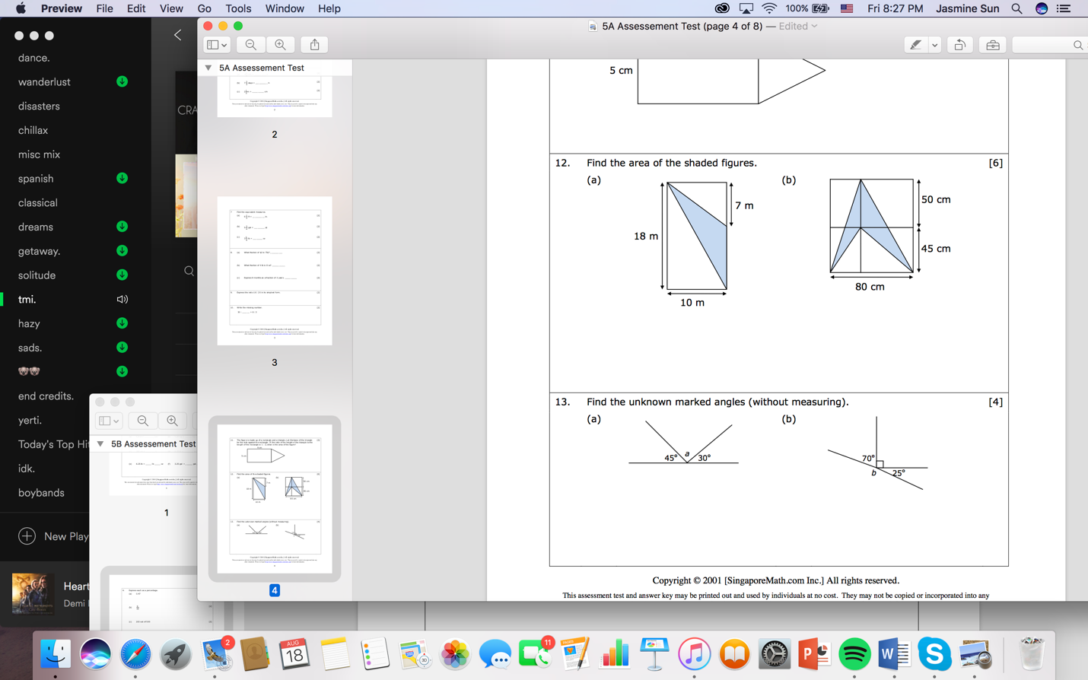105 degrees

Diagnostic Test Answers

1. 28,000
2. -2
3. 104.49
4. 0.203
5. 3/32 (must be simplfied)
6. 22/9 (must be simplified)
7. 43%
8. 48 seconds
9. 3/8 (must be simplified)
10. 15
11. 15
12. 60 cm
13. $68
14. ${12}^{3}$ cubic inches
15. 55 square meters
16. 105°